Remote Database Synchronization with Microsoft Office and Microsoft BackOffice
This paper discusses a solution for synchronizing remote databases using Microsoft Access, Microsoft SQL Server, ODBC, and Microsoft Mail.

Overview
Sharing data among multiple users typically requires that all users are connected to the same data source [server or database management system or DBMS]. In some situations, multiple users (clients) need to have a copy or “slice” of the data on their remote PC due to practical or performance reasons. However, they need to receive and deliver data updates to ensure that the remote data "slice" and the corporate database are accurate. In summary, the remote clients and server must identify new or modified information and implement the changes accordingly.
A large outside sales department is a good model. A large sales force, (which is mostly mobile) logs a great deal of information about their daily calls, product information, contact information changes, etc. Because the sales force is remote, these changes are immediately recorded only on their personal machines, not to the master database. The corporate office can use this up-to-date information to enhance customer service, track customer activity, identify opportunities, etc. This information exchange can also provide feedback about sales performance, customer trends, product information and sales information to the remote users in the field.
Synchronization allows the remote user the benefits of a stand-alone system, while giving the corporate office up-to-date information on each of it’s customers.
This paper and accompanying code present a database synchronization strategy/solution using Microsoft Access 2.0 as the remote client, Word for Windows as the forms manager, Excel as the sales analyzer and “number cruncher,” Schedule+ to track appointments and Back-Office [NT Server, SQL Server and Mail] to synchronize and track enterprise data. It is directly dependent upon messaging and OLE automation technology.
To best understand the entire scope of this application, it will help to look through the source code for both the Access component and the C++ component (that is DBSYNC.DLL). Also, before you begin using the application, you will need to read SETUP.TXT.

Development Considerations
The final solution, “DBSync Contact Manager,” was built in about 2 weeks, with the following considerations.
• Since the remote datasource (client) and main datasource (server) are different types of database management systems, a common API, ODBC, is used as a programming interface for the bulk of the synchronization process.
• The users of the system are not required to “operate” the synchronization process, it will be nearly unnoticeable to the user. (An overview of the user interface follows.)
• The administrator of the system is not required to “operate” the process either, the DBSync system will handle it’s own confirmation and application of data changes.
• Users must have the ability to synchronize with server data transparently, without any additional effort (or training), preferably during the course of their daily activities. (i.e. Mail)
• The network server where the server data resides should not be normally accessible to the user. (via RAS (Remote Access Service) or other some other remote protocol.) Instead, a remote user’s only “link” to the server data is through Microsoft Mail. This enhances network security.
• The length of time connected must be kept to a minimum—a user will connect, send the new data, and disconnect. (Remote Mail lends itself to this rather well.)
• Changes made by “related” users—those users sharing responsibility on a customer—the user’s managers, and SQL Server users need to be included in the synchronization process.

The DBSync Contact Manager User Interface

General Feature Outline
The DBSync Contact Manager application is intended to be used as a guide and model for solutions that can be achieved using the Microsoft Office/BackOffice/Language tools. A brief tour of the application “features” may help you better understand the scope and purpose of the development.
• The application is centered around “Customers” and “Users.” Users interact and, we hope, sell to, Customers.
• More than one user may “work” on a single Customer. The relationship between the two is defined by the table “UsersCustomers.” In order to “own” a Customer, a User needs only to have an entry in the UsersCustomers table.
• Users interact with Customers through “Contacts” (an individual acting as a representative of the Customer) and each user records their daily activities and communications with each Customer through “Notes.” A Customer can have many Contacts and Notes.
• The user interface lets Users work with Customers as a group or individually. The User can select a single customer, (All) Customers, or (All) User’s Customers.
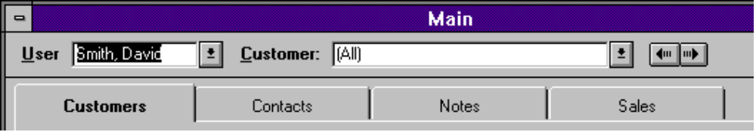
Figure 1: Tab control used to organize functional work areas in DBSync Access application.
• Each User may have one or more other related Users in their database.
• Major areas of functionality are divided into four “Tabs” or pages of the Main form, Customers, Contacts, Notes, and Sales.
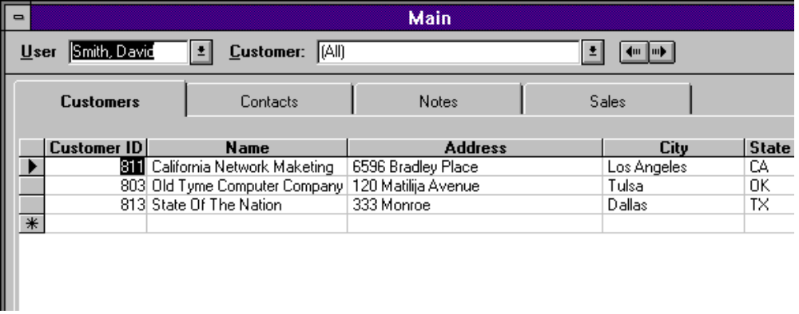
Figure 2: Viewing all contacts for all customers for user David Smith
• By selecting different pages of the form you can see all Customers, All Contacts, or All Contacts for a Customer, or All Notes for a Customer, etc.
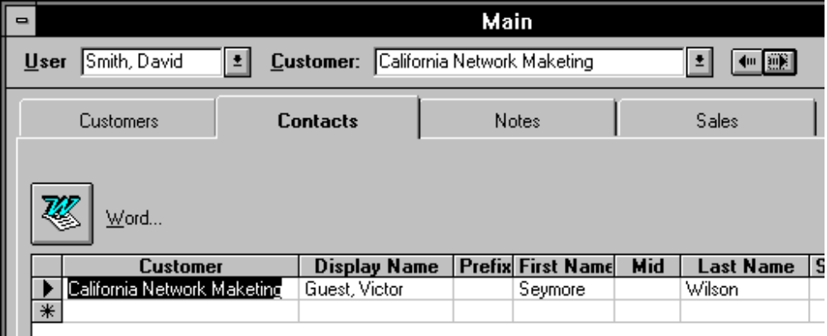
Figure 3: Viewing contacts which belong to customer California Network Marketing
• Users correspond (letters, faxes, ...) with Contacts. Using OLE automation, and Microsoft Word for Windows, the application provides a way to "automatically" send letters and fax cover sheets to a specific Contact or all the Contacts in the datasheet.
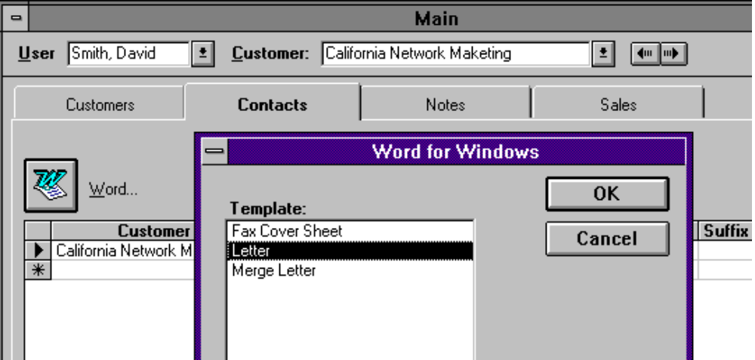
Figure 4: Setting up a letter using Word for Windows and OLE Automation
• When a letter is sent to a single Contact, a Note is added to the Notes table and the name of the file is stored with the Note. The file may be retrieved later (using OLE automation) for review.
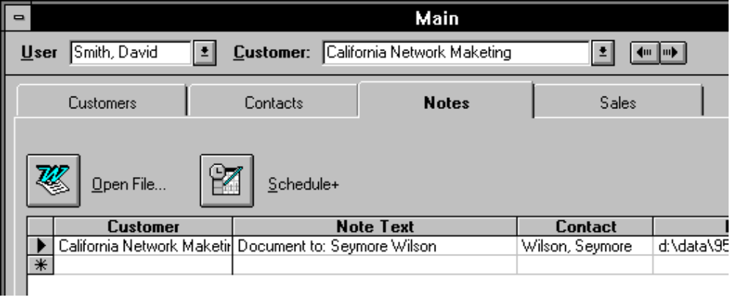
Figure 5: Using Access to track documents created through mail merge or letter creation
• Notes can be entered automatically, such as sending a letter or by adding it directly into the datasheet.
• Additionally, the User may choose to “schedule” the Note (a meeting or phone call for instance) by using Microsoft Schedule+. DBSync Contact Manager schedules a 1 hour appointment into the current user’s calendar, starting at the time specified by the Note Date.
• Finally, Customers purchase products, or at least the good ones do, and most Users want to see the sales numbers.
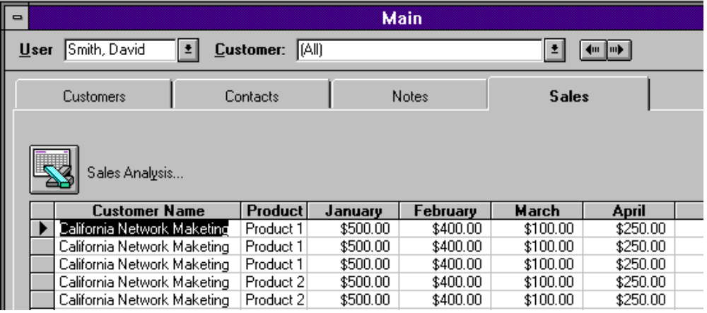
Figure 6: Viewing sales figure for all customers
• Using OLE automation and Microsoft Excel, a User can further analyze these sales numbers utilizing Excel charts and pivot tables.

Microsoft SQL Server (BackOffice)
• Using ODBC and Access, the datasource can be changed from a remote (Access) “slice” of the database, to a total corporate picture of the data. Using this method, many local users can benefit from the information while their changes are reflected and distributed to the remote users.
• The application automatically establishes a secure connection with the SQL server opening up the application to a much larger potential on-line group of users.
• Which database to connect to is indicated by the application’s .INI file (DBSYNC.INI in this case). Each time the application is started, the [AttachedData] section of DBSYNC.INI file is queried for the remote datasource/database—if the database file exists, then the connection is local, if it doesn’t, the setting “DSN=” is queried for the ODBC datasource name to use for data.
From the DBSYNC.INI file:

[AttachedData]
;to use local tables for a datasource
DataDB=c:\dbsync\dbxdata.mdb
SalesDB=c:\dbsync\dbxsales.mdb

;to use SQL server for a datasource comment out the previous two lines
DSN=DBSYNC_SQL32
DatabaseName=db_dbsync

From AccessBasic Module: Main, procedure UpdateAttachments():

sRemoteDB = GetProfileString(IDS_INISEC_ATTACHEDDATA, IDS_INIKEY_DATADB, "")
sSalesDB = GetProfileString(IDS_INISEC_ATTACHEDDATA, IDS_INIKEY_SALESDB, "")

If (FileExists(sRemoteDB) And FileExists(sSalesDB)) Then

' attach the local tables

Else

tGlob.sDSN = GetProfileString(IDS_INISEC_ATTACHEDDATA,
IDS_INIKEY_ODBCDSN, "")
tGlob.sDatabaseName = GetProfileString(IDS_INISEC_ATTACHEDDATA,
IDS_INIKEY_ODBCDATABASENAME, "")

tGlob.sDSN = "ODBC;DSN=" & tGlob.sDSN & ";DATABASE=" &
tGlob.sDatabaseName
tGlob.sDSN = tGlob.sDSN & ";UID=" & GetNetworkUserID()

tGlob.bRemoteIsODBC = True

' attach the SQL Server tables

End If

Admin Tools
• After the database is created, each remote user needs his or her “slice” of the data. The “make database” process copies the appropriate data from SQL server into new databases to be sent to each user.
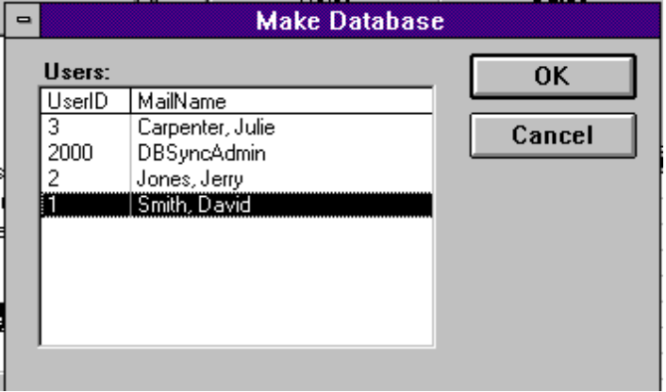
Figure 7: Making Database for David Smith

Distribution of the Transactions
• Once a day, the outstanding transactions (changes) are sent to the Users affected by the change. This includes any “team” Users, Managers of the Users, … A simple form is opened and this form creates and maintains a timer that fires a distribution process once a day.
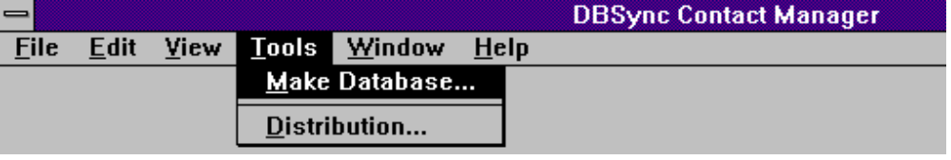
Figure 8: Admin options to make database and control distribution.
• This process also handles the sending of confirmation messages back to the remote users who have “synchronized” their data.

Software Components
With the above considerations in mind, the following components are used.
• Client software: Microsoft Office, primarily Microsoft Access 2.0 (both local and remote users)
• Transport: Microsoft Mail Remote (remote users) using Custom Messages sent via the simple MAPI interface.
• Server: Microsoft SQL Server, Microsoft Mail 3.x (as the process “administrator”)
• Languages: Microsoft Visual C++ version 1.51 (and 2.0 for the 32-bit operations)

Synchronization Implementation Details

Abstract
As each change is made to the database, (in Microsoft Access 2.0), a “transaction” is recorded with the changes. Each transaction records the time, user identification, and type of change.
At the end of a “session,” (user’s interaction with the database) or a menu command, the outstanding “transactions” are packaged into a file and sent (E-mailed) to the SQL Server counterpart.
These files are then stored on the local machine until a confirmation is received from the server. The confirmation message is sent (via Microsoft Mail) and the file is deleted from the user’s machine. If outstanding files are still on the local machine when a new file is sent, the outstanding (un-confirmed) file is sent first.
On the server side, a single mail client receives the messages. When the message is received the file is “unpacked,” and the transactions are applied to the server. Each successfully applied transaction is stored for future distribution to related users.
Once the changes have been successfully applied, an “log” entry is made in the database to prevent the re-application of the same changes.
On a regular interval, confirmation messages are sent to users and the “applied” log entry is deleted. If the confirmation fails, the file is sent again from the remote user and the entire process starts again.
The applied changes (transactions) are stored in another table for distribution to other remote users. (Managers, related users, etc.) Once a day, the transactions are ordered by date and distributed to the related users.
When these changes are received (as part of the connection to Mail) they are applied to the client’s database. The client sends a similar confirmation message to the server, removing the server’s local copy of the transaction file.

Transaction Logging Details
There are three types of changes that can be made to data in a database, INSERT (or add), UPDATE (or change), or DELETE. Microsoft Access fires an form level “event” for each of these changes. As each event occurs, the key information is stored in an attached table.
For INSERT changes, only the Primary key columns and values are stored in the transaction table.
For UPDATE changes, the updated columns are also queried and stored to minimize the chance of overwritten rows when data is shared between many users.
For DELETE changes, Access sends two messages, one that the row has been deleted, and then one that either confirms or cancels the delete. The DBSync code logs the transaction as if it were deleted, then marks it as “confirmed” if the delete is confirmed, or deletes the transaction(s) if the event was canceled by the user.
Additionally, the current user (by number) and the CustomerID is also stored for each transaction. This allows the DBSync process to avoid sending the same change back to the user who made the change, and helps build the related user list when distributing the transactions.
On every form that is involved in the DBSync process, you will need to store a form level variable of type DBSYNC_INFO and handle the following events: Form_BeforeUpdate(), Form_AfterUpdate(), Form_Delete(), Form_AfterDelConfirm(), Form_AfterInsert(). For each of these events you will call dbx_OnRowChange() with a reference to the form (caller) and reference to the DBSYNC_INFO structure.
Almost all of the transaction events happen from a form, but the DBSync code also provides a programmatic method of logging a transaction.
Example (from the Customers_datasheet form):

Sub Form_AfterInsert ()
On Error GoTo Form_AfterInsert_Error

Dim rs As Recordset
Dim sSql As String

'log the customer table change
dbxInfo.nStatus = DBSYNC_INSERT
dbx_OnRowChange Me, dbxInfo

'Now add a related row into the UsersCustomers table so that
'this customer will show up in this users list
Set rs = db.OpenRecordset("UsersCustomers", DB_OPEN_DYNASET, DB_APPENDONLY)

rs.AddNew
rs("UserID") = tGlob.lUserID
rs("CustomerID") = Me.CustomerID
rs.Update

rs.FindFirst "UserID = " & CStr(tGlob.lUserID) & " and CustomerID = " & CStr(Me.CustomerID)
If (Not (rs.NoMatch)) Then
dbx_LogTransaction rs, DBSYNC_INSERT 'log the transaction
Else
DoMessageBox IDS_E_ADDUSERCUSTOMER
End If

Form_AfterInsert_Exit:
If (Not (rs Is Nothing)) Then rs.Close
Set rs = Nothing

Exit Sub
Form_AfterInsert_Error:
GenericError "Customers_datasheet: Form_AfterInsert()", Err
Exit Sub
End Sub

Transaction SQL statements
After all the changes have been logged (for the session, or day, etc.) call dbx_SetTransTableSQL() to prepare the transactions for the synchronization process. In practical terms, this means walking back through the Primary Key names and values for each transaction and building an ODBC run-able SQL statement that reflects the changes.
In some cases, the row that the SQL statement is being built from will be unavailable. For instance, DELETE changes are simply written to the transaction table without looking for the (deleted) row.
Also, because each transaction is logged as it happens, a row may be unavailable because it was first INSERTED, then UPDATED, then DELETED. In this case, the transaction is not sent.

Referential Integrity
A transaction is recorded for the primary table in the affected recordset only. (This is determined by the dbsyncid column in the recordset). Since each transaction is recorded against only this one table at a time, it is essential that the SQL server provides the exact functionality of the Jet engine—mainly referential integrity triggers and cascading updates and deletes.
There has been no attempt to “reproduce” the engine level functionality in the DBSync implementation. Instead, the Microsoft Upsizing Wizard was used to make a “duplicate” of the affected database.

Handling the INSERTs
In a remote system such as this, it becomes important that each user have their own “range” of new row identifiers (or PrimaryKey values). Typically, an Access “counter” column is used, but in this case, the chance for duplicates is certain.
The solution is to give each user a “range” of new ids, based on their user id. In the DBSync Contact Manager a function called GetNewID() is used to give each user a range of 1 million new id’s in any one table.
Before each insert event, GetNewID() is called and the return value is assigned to the appropriate column. Example: (from the Customers_datasheet form)

Sub Form_BeforeUpdate (Cancel As Integer)
Me.DateModified = Now
If (IsNull(Me.CustomerID)) Then
Me.CustomerID = GetNewID(ID_TABLE_CUSTOMERS, "CustomerID")
End If
dbxInfo.nStatus = DBSYNC_BEFORE_UPDATE
dbx_OnRowChange Me, dbxInfo
End Sub

Microsoft Mail

Custom Messages
A custom message is a special class or type of message used to exchange information between Mail recipients or Mail-aware applications.
The DBSYNC.DLL processes three types of custom messages: DBSync, DBSyncToCorp, and DBSyncConfirm. When a message of any one of these types arrives in the in-box, Mail calls a single function in DBSYNC.DLL, Command().
After the Command() function is called, DBSYNC.DLL establishes a session with Mail (by logging on), reads the custom message, saves the attached file and, using ODBC, applies the SQL statements from the file to the appropriate datasource.
If the file is processed without error, the message is deleted, with no user intervention.
If the message is a DBSyncConfirm (or confirmation message) the message body contains a file name (prefaced by a user ID if it is sent by a remote user). When the message is processed, DBSYNC.DLL looks in the DBSYNC.INI file for the path to the local storage of .DBX (transaction) files. If the file exists, then it is deleted. This prevents the file from being sent an additional time.
The custom message types need to be registered in the remote user’s MSMAIL.INI file:

IPM.DBSync.DBSync=3.0;;;;<system>dbsync.dll;;2122222100000000;;;;
IPM.DBSync.DBSyncToCorp=3.0;;;;<system>dbsync.dll;;2122222100000000;;;;
IPM.DBSync.DBSyncConfirm=3.0;;;;<system>dbsync.dll;;2122222100000000;;;;
Strictly speaking, only two of these settings are required, depending on what type of database you are using. For the remote users, only the first and third are required. For the SQL Server Mail client (there should only be one) only the second and third lines are required. In a production environment, you should avoid the second message declaration on the remote user's machines.
The series of numbers (16) indicate when the custom .DLL is to be called. In most cases, the 8th position, which represents a delivery operation (a message of this class has arrived in the in-box) is all that will be acted upon by the dbsync process. However, in case of unexpected failure, the second position, which represents an open operation (a user double-clicks on the message) also causes Mail to call the custom .DLL and process the message. This can be useful if you are testing the process.
For additional information on utilizing Microsoft Mail, consult the Microsoft Mail Technical reference.

About Moss Micro
Moss Micro has been designing and building custom software applications since 1987. The primary development focuses on the Microsoft suite of applications and tools such as Visual Basic, Word, Excel, Access and SQL Server. Other Windows NT and UNIX databases, such as Sybase and Oracle are supported along with a variety of front end products and programming languages. The rapidly growing staff of Moss Micro, now numbering 27, represents over 85 years of software development experience.
 | Moss Micro  31952 Camino Capistrano  Suite C22  San Juan Capistrano, CA 92675  Phone: 714-248-1701  Fax: 714-248-0203

See the section on Admin Tools.
Provided that the file still exists. (Sort of a poor man’s document manager.)
Schedule+ must be running. (Also, this feature is only available under Windows for Workgroups.)
See the UpdateAttachments() function in the Main module for code examples.
See the dbsync.sql script and/or the resulting database for details.
Note that this limits the number of users to about 2,000.
For details see the DBSYNC.DLL source files.
Setup will set these settings. (See the setup.txt for details)

